CSA1509-Cloud computing and Big Data Analytics
Name : P Preethi
Reg.no: 192521178

EXP 14 : Create a Virtual Hard Disk and allocate the storage using VM ware
Workstation.
Aim:
To Create a Virtual Hard Disk and allocate the storage using VM ware
Workstation.
Steps:
- Download VMware software and install it as Type-2 Hypervisor.
- Download Ubuntu or tiny os as ISO image file.
- In VMware workstation Create new VM
- Do the configuration based on given conditions.
  - Add extra Hard disk and allocate Storage to it .
- Created a virtual Machine .
- Launch the VM.
Implementation:
- Download and open VMware software.
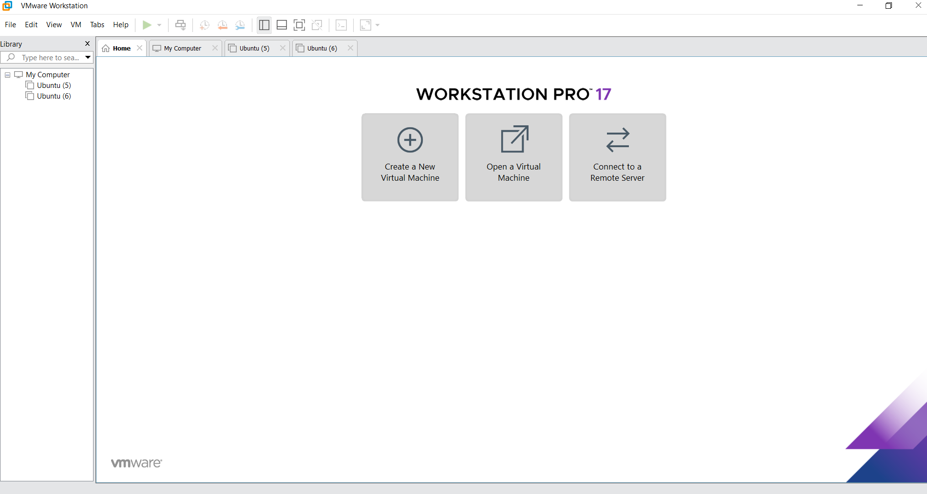
2.Create a new VM

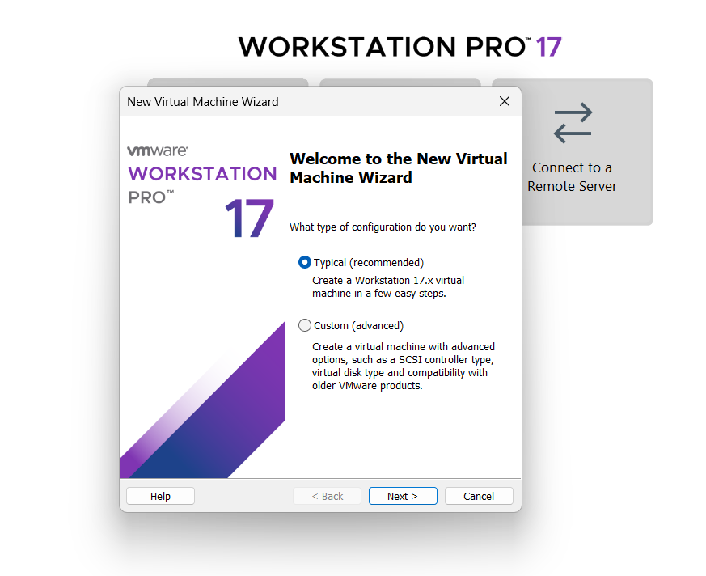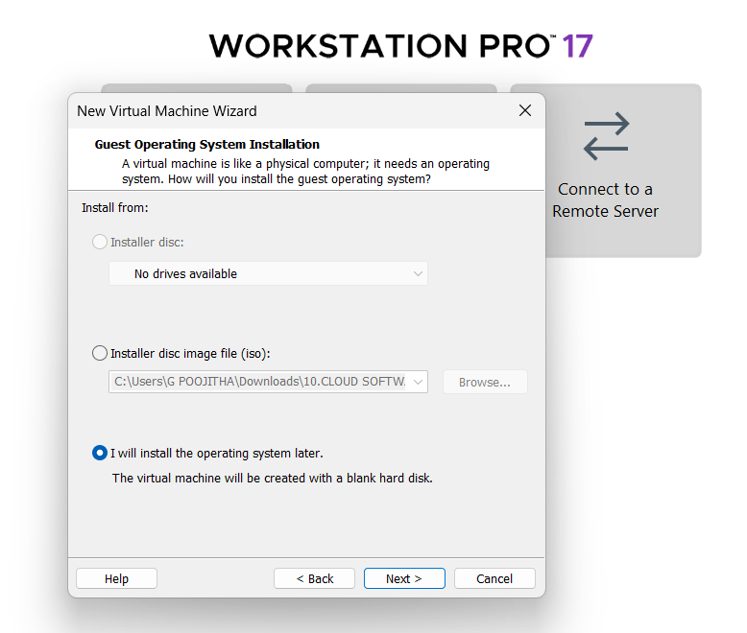
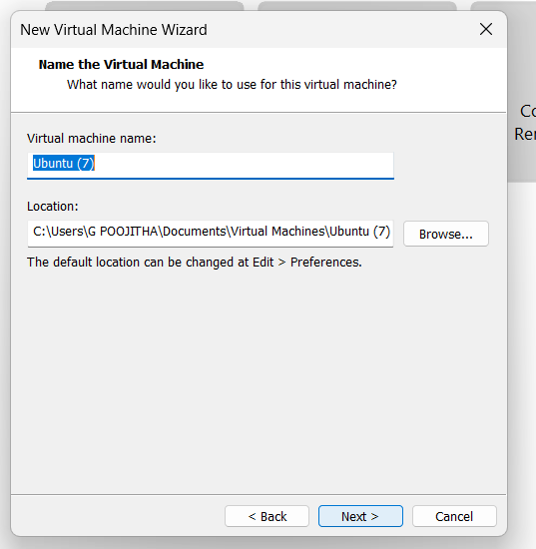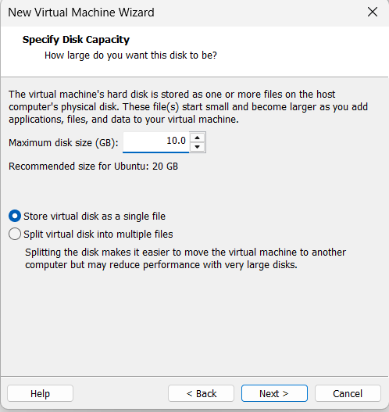
Name it anythingclick on nextAdjust the size of disk change the option to first and then click on next.
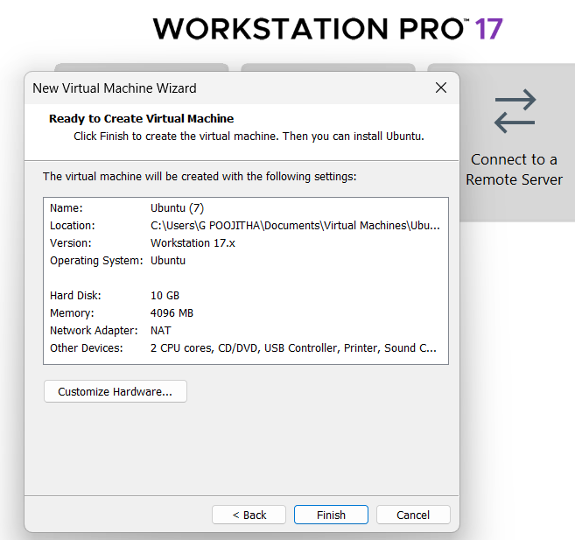 Click on Finish to Launch .
3.VM is created
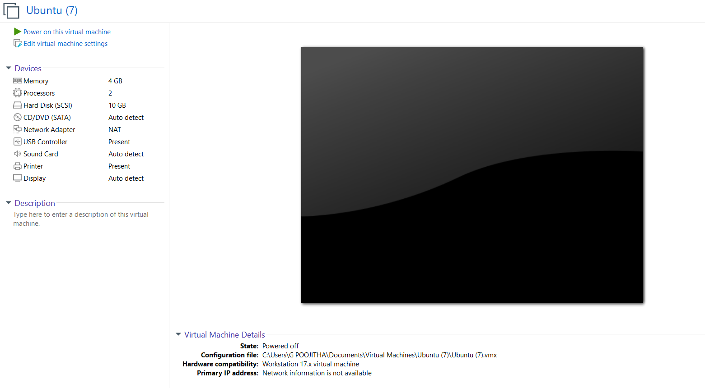
4. Double-click on Hard disk and Click on add and create a new Hard disk
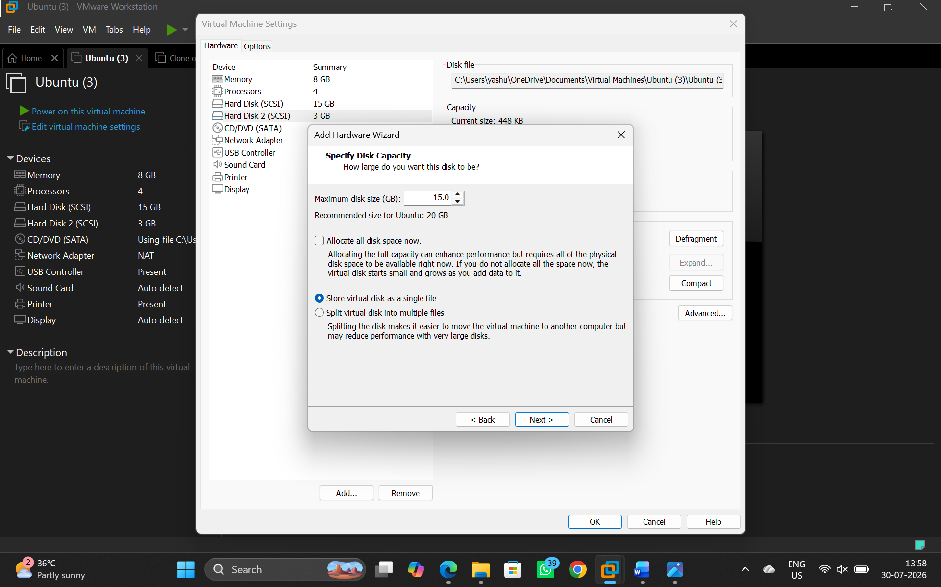

6. VM is created according to the conditions given.
